When I click the red line in overview I’ll see the failures unde the investigate menu

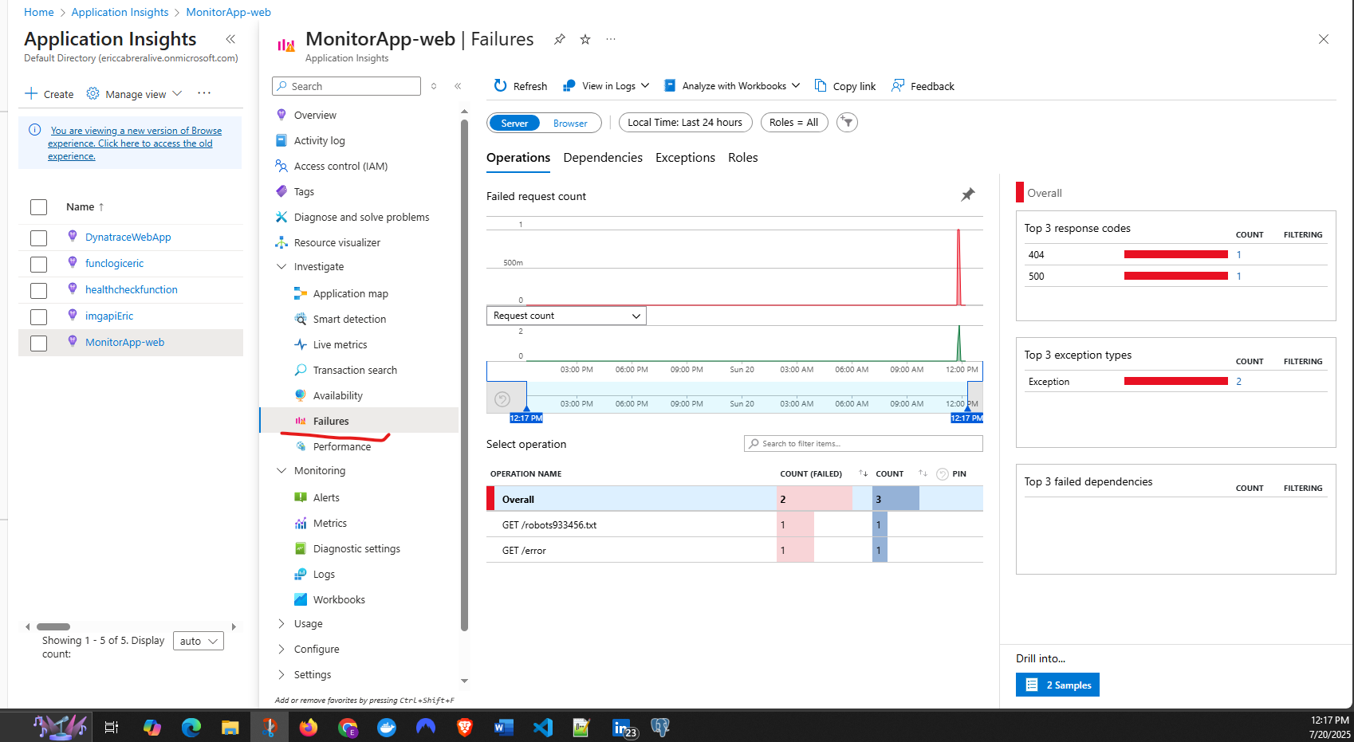

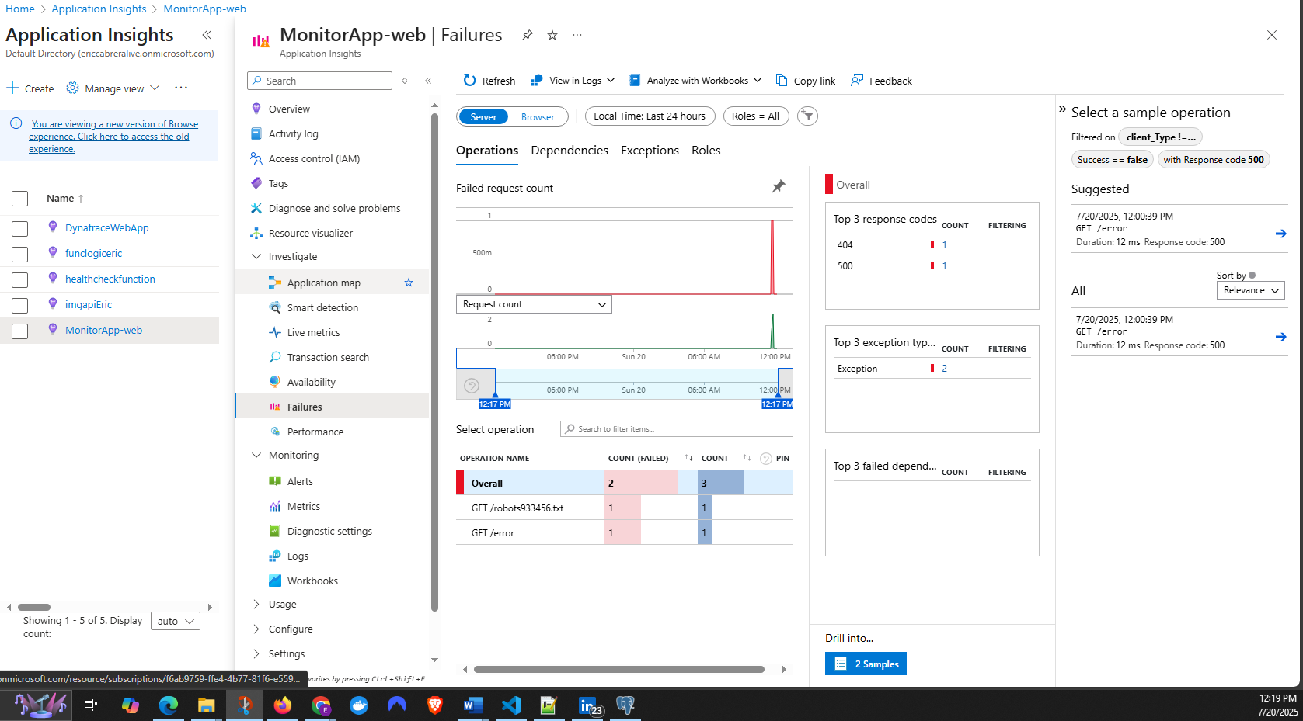

If I click

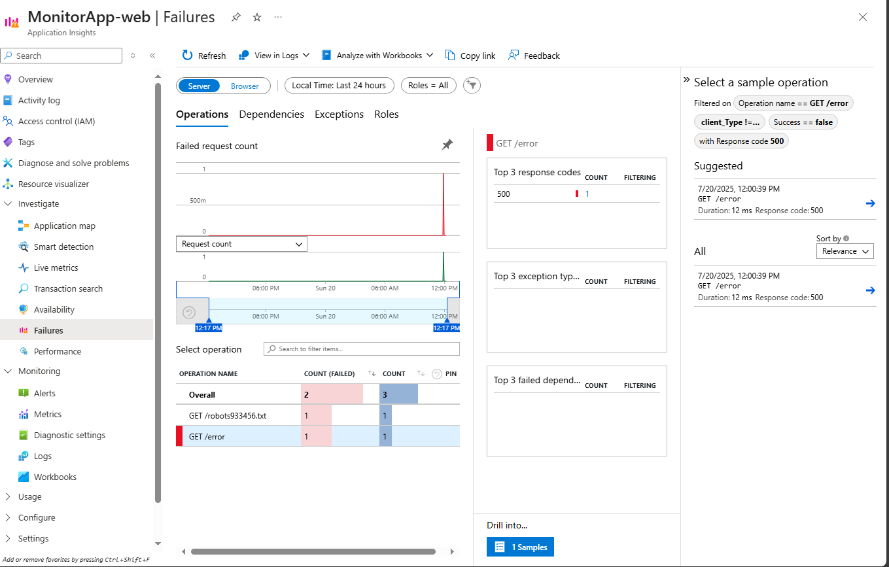

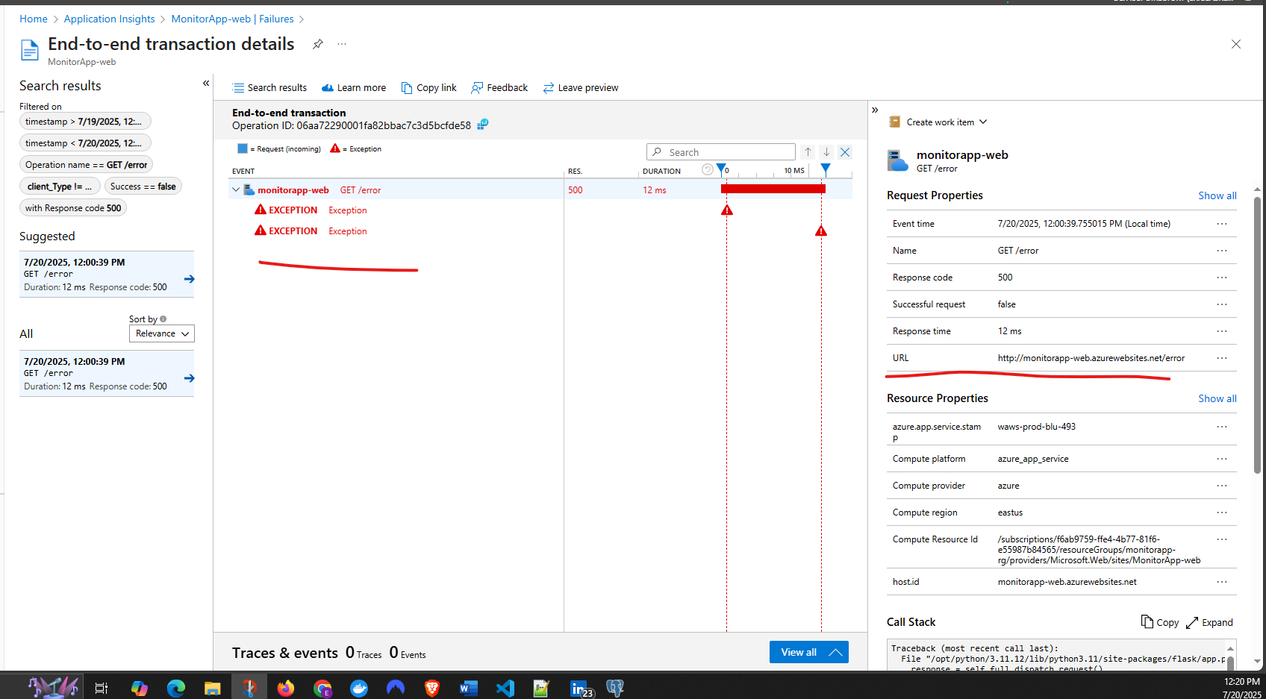

Call Stack

Here I will be able to see I which line the exception occur

Traceback (most recent call last):

File "/opt/python/3.11.12/lib/python3.11/site-packages/flask/app.py", line 1511, in wsgi_app

response = self.full_dispatch_request()

^^^^^^^^^^^^^^^^^^^^^^^^^^^^

File "/opt/python/3.11.12/lib/python3.11/site-packages/flask/app.py", line 919, in full_dispatch_request

rv = self.handle_user_exception(e)

^^^^^^^^^^^^^^^^^^^^^^^^^^^^^

File "/opt/python/3.11.12/lib/python3.11/site-packages/flask/app.py", line 917, in full_dispatch_request

rv = self.dispatch_request()

^^^^^^^^^^^^^^^^^^^^^^^

File "/opt/python/3.11.12/lib/python3.11/site-packages/flask/app.py", line 902, in dispatch_request

return self.ensure_sync(self.view_functions[rule.endpoint])(**view_args) # type: ignore[no-any-return]

^^^^^^^^^^^^^^^^^^^^^^^^^^^^^^^^^^^^^^^^^^^^^^^^^^^^^^^^^^^^^^^^^

File "/home/site/wwwroot/app.py", line 15, in error

raise Exception('Intentional error for Application Insights demo!')

Exception: Intentional error for Application Insights demo!